Theme color:

Red: #ED3E2A

Green: #9CBD9C

Grey: #5D5455

Yellow: #FCE9DB

White: #FFF

Skin tones (main color, first shade, darkest shade):

- Pale: F4DAC9, F4C19F, EAAA86

- Yellow: FECE93, F7B889, F29E66

- Yellow-brown: E2B096, #d49f83, #b37d60

- Brown:

- Black:

Hair/Eyebrow/Beard Colors:

- Blonde: E5D876

- Brunette: 846147

- Black: 42403F

- Grey: 898989

- Orange (redhead): BC5815

Fonts:

1st Helvetica

2nd Myriad Pro

size: 16px

h2-size: 22px bold

Elements:

Accessories:

1. antlers class: accessories antlers;
2. earrings class: accessories earrings;
3. 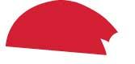Xmas_hat class: accessories Xmas_hat;
4. Xmas_nose class: accessories Xmas_nose;
5. scar class: accessories scar;
6. glasses class: accessories scar;
7. blush class: accessories blush;

Eyes:

1. eye 1 class: eyes eye1; id: eye1_blue eye1_black;
2.  eye 2 class: eyes eye2; id: eye2_blue eye2_black;
3.  eye 3 class: eyes eye3;
4.  eye 4 class: eyes eye4;
5.  eye 5 class: eyes eye5;

Mouths:

1. mouth 1 class: mouths mouth1;
2. mouth 2 class: mouths mouth2;
3. mouth 3 class: mouths mouth3;
4.  mouth 4 class: mouths mouth4;
5.  mouth 5 class: mouths mouth5;
6.  mouth 6 class: mouths mouth6;

Eyebrows:

1. eyebrow 4 class: eyebrows eyebrow4;
2. eyebrow 3 class: eyebrows eyebrow3;
3. eyebrow 2 class: eyebrows eyebrow2;
4. eyebrow 1 class: eyebrows eyebrow1;

Beards:

1. beard 2 class: beards beard2;
2. beard 1 class: beards beard1;

Hairstyles:

1. 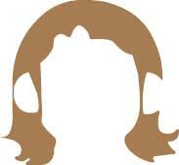hair 6; class:hairstyles; id:hairstyle6;
2. 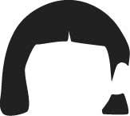hair 5; class:hairstyles; id:hairstyle5;
3. 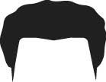hair 4; class:hairstyles; id:hairstyle4;
4. 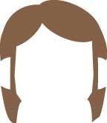hair 3; class:hairstyles; id:hairstyle3;
5. 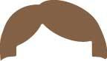hair 2; class:hairstyles; id:hairstyle2;
6. 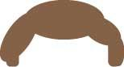hair 1; class:hairstyles; id:hairstyle1;
7. 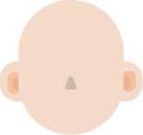face shape; class:face; id: ear_light ear_mid ear_dark face_shape nose;